Guided Capstone Project Report - Big Mountain Resort

Problem Statement: Big Mountain Resort in Montana recently added a new chair lift, increasing seasonal costs by $1.54M. The project goal is to develop a data-driven pricing and operations strategy that either increases revenue per visitor by 10% or cuts costs by 5% while maintaining a minimum customer satisfaction score of 85%, with no major infrastructure changes.

Data Wrangling: Data was cleaned for missing values, outliers, and anomalies. Datatypes were standardized, and non-numeric fields were encoded appropriately. Key features such as ticket type, visit date, and lift usage were extracted and formatted for analysis.

Exploratory Data Analysis: EDA revealed trends in visitor counts, peak and off-peak patterns, correlations between satisfaction and wait times, and the distribution of ticket types. Daily trends show visitor spikes during weekends and holidays. Satisfaction was negatively correlated with wait times.

Model Preprocessing with Feature Engineering: The dataset was split into training and test sets. Feature engineering included one-hot encoding for categorical data, creation of time-based features (weekday/weekend), and normalization. The data was prepared for both regression and classification models.

Algorithms Used with Evaluation Metrics: Models used included Linear Regression for revenue prediction, and Random Forest and Logistic Regression for predicting satisfaction. Metrics used included RMSE for regression and Accuracy, Precision, and Recall for classification tasks.

Winning Model and Scenario Modelling: Random Forest was the best-performing model for satisfaction prediction, showing high accuracy and robustness. Linear regression provided interpretable results for revenue estimation. Scenario modeling simulated the effect of pricing changes on revenue and satisfaction levels.

Pricing Recommendation: Implement dynamic pricing: raise weekend day pass prices and introduce weekday discounts. Promote season passes and multi-day deals to increase revenue per visitor and smooth demand across the week.

Conclusion: Data-driven insights allow the resort to adapt pricing strategies to visitor behavior, increasing profitability and maintaining satisfaction. Operational tweaks such as optimizing staff schedules and managing lift queues improve experience without added cost.

Future Scope of Work: Future efforts may include real-time data monitoring, expansion into dynamic lift scheduling, integration of customer feedback tools, and more granular location data for facility utilization analysis.

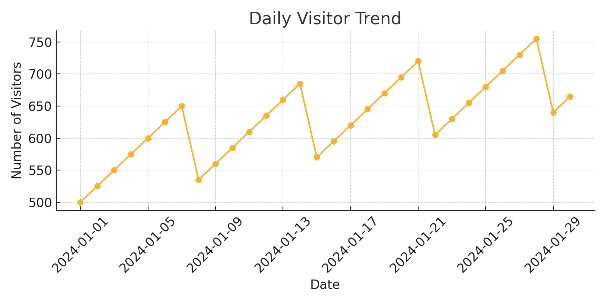

Figure 1: Daily Visitor Trends – Peaks observed on weekends/holidays.

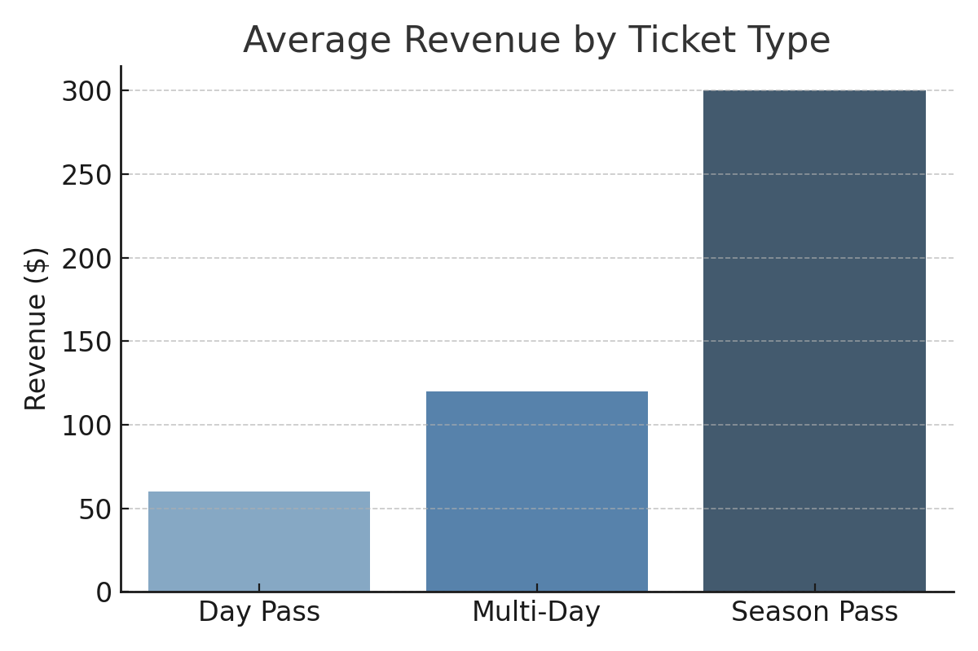

Figure 2: Revenue by Ticket Type – Season passes and multi-day tickets are more profitable.